**Table Creation (DDL Operations)**

|  |  |  |
| --- | --- | --- |
| Student ID1: 23-51951-2 Name: Rimtaha Saima Nushin | StudentID3: 23-52794-2 Name: Kazi Ayesha Afia Rayeesa | |
| StudentID2: 23-52674-2 Name: Abdullah Al Kafe | StudentID4: Name: | |
| **CO4**: Creating DML, DDL using Oracle and connection with ODBC/JDBC for existing JAVA application | | |
| **PO-e-2:** Use modern engineering and IT tools for prediction and modeling of complex computer science and engineering problem | | Marks |

## Provide the screenshots of your commands for created tables in oracle.

1. For creating Product Table:

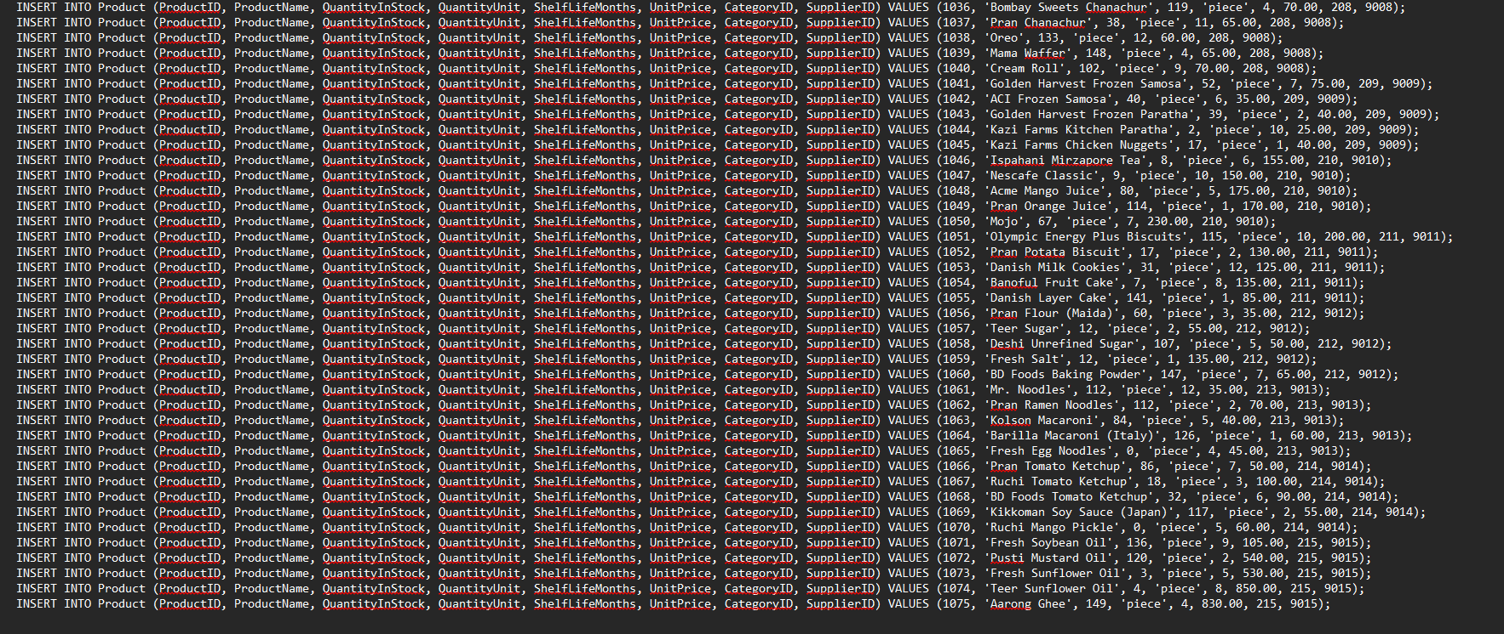

1. For creating Category table:

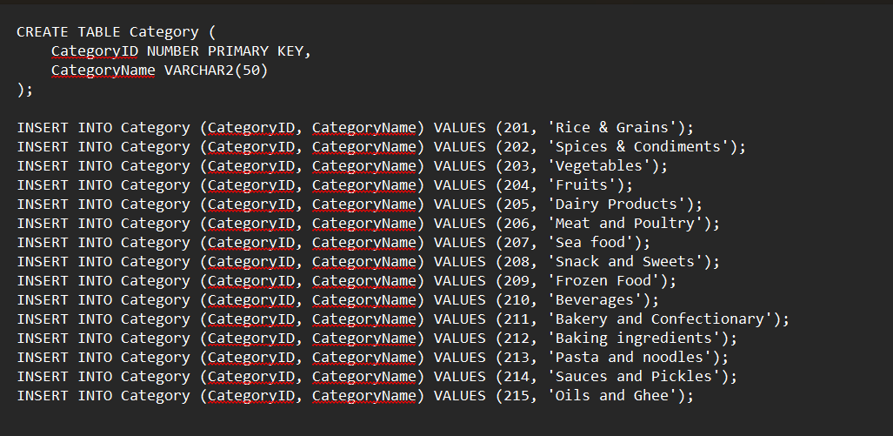

1. For creating Supplier table:

1. For creating Supplier contact table:

1. For creating supplier district table:

1. For creating Storebranch table:

1. For creating manager table:

1. For creating Restocking table:

## Provide the description which shows the structure of the table.

1. PRODUCT TABLE:

1. SUPPLIER TABLE:

1. CATEGORY TABLE:

1. RESTOCKING ORDERTABLE:

1. Supplier contact details table:

1. Supplier district table:

1. Manager table:

1. Storebranch Table:

**Inserted Values in the tables**

## Give the screenshot of all the created tables in Oracle. All the tables should be attached one by one.

1. A screenshot of a computer

   Description automatically generatedA screenshot of a computer

   Description automatically generatedPRODUCT TABLE:

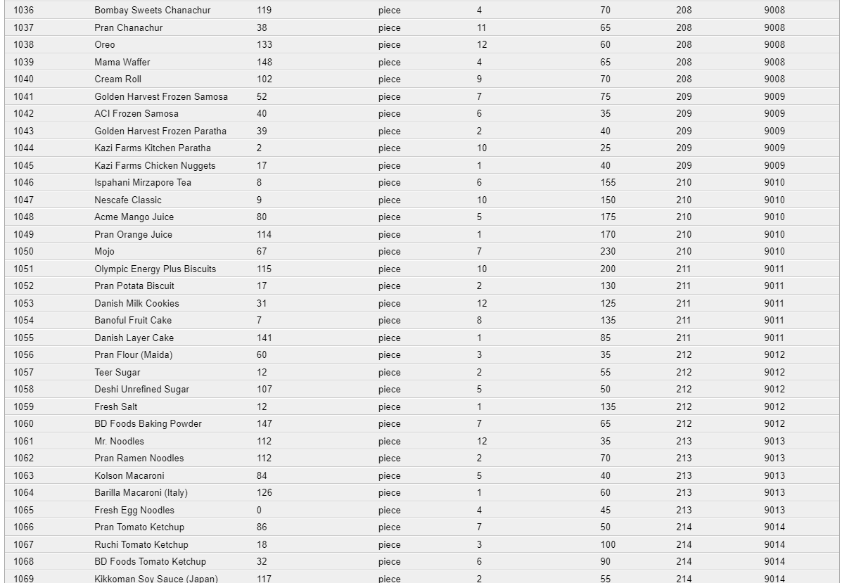

2 Supplier table:

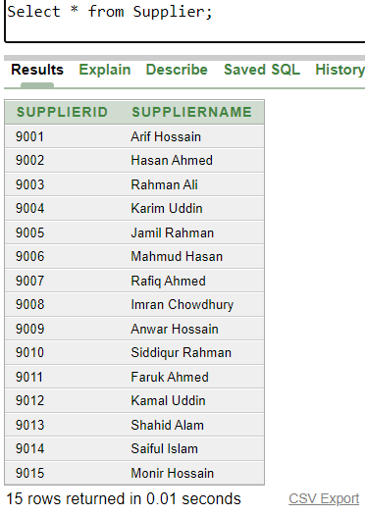

1. Category table:

1. Supplier contact table:

1. Supplier district table:

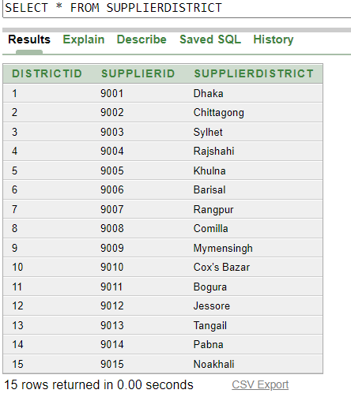

1. Storebranch table:

1. Manager table:

1. RESTOCKING ORDER TABLE:

**Query Test in DB**

## There will be one simple query. One with Group/ Aggregate function, 2 single row Subquery, 2 Multiple Row subquery, 4 different type of joining.

1. simple query
2. Query with a single row function
3. Query with a Multiple row function/ aggregate function
4. 2 Single row subquery and 2 multiple row subquery
5. 4 kinds of joining

1 simple view  
1 complex view  
  
## Provide query first, next the command for the query and at last the output:  
  
In the end show a simple view and a Complex view:  
Demo of a simple view is given below:

SIMPLE VIEW:  
  
🡪 create a view named as eview30 where the deptno 30 will be shown over the columns ename, empno and deptno

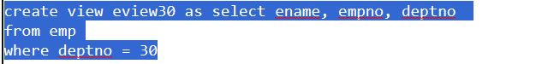

fIG: Simple view creation command   
  
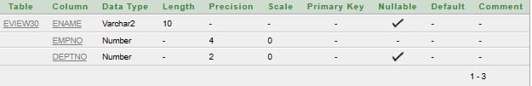

fig: Description of the simple view

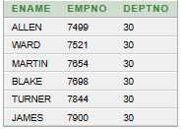

Fig: Result of the simple view as a whole table

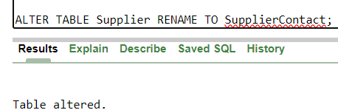

**Description of a Successful DB connection**

## Its up to the presentation / explanation capabilities of the student. Each student has to show the DB connection process individually and put the description in this file one after another mentioning their name. Student can use either MySQL or Oracle.

what do we need?  
1. Mysql java connector (jar file)

You can go to “**mysql java connector maven” any version you like**2. You need to search (**xampp apache mariadb perl php**) install xampp server normally

3. Select the xampp icon control UI and then **start** both apache and mysql. Next go to mysql admin panel

4. now create a Database , inside of it create table and insert the values in the table

The table in mysql  
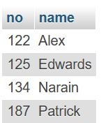

Now we need an IDE.

Before that, we need to understand the steps of DB connection

* Register Driver
* Connect the DB
* Create statement
* Execute the query () in the resultstmnt
* Connection close ()

5. Now write the DB connection code and **add the jar file location in the libraries**

The output will be  
